1. What is Network Management?
Definition
Network Management is the process of deploying, integrating, coordinating, monitoring, configuring, analyzing, and controlling the hardware, software, and human resources of a computer network to ensure efficient operation, good performance, and security at a reasonable cost.
Easy-to-remember: Network Management is the process of monitoring, maintaining, configuring, and securing a computer network so that it operates efficiently and reliably.

1.1 Why is Network Management Needed?
Without network management:
- Network failures cannot be detected quickly.
- Performance decreases.
- Security attacks become difficult to identify.
- Configuration errors increase.
- Troubleshooting becomes time-consuming.
Hence, network management keeps the network efficient, reliable, and secure.
Image :

2. ISO FCAPS Model
Definition
The FCAPS model is a network management framework developed by the International Organization for Standardization (ISO). It divides network management into five functional areas to simplify the monitoring, maintenance, and administration of computer networks.

FCAPS stands for:
- F – Fault Management
- C – Configuration Management
- A – Accounting Management
- P – Performance Management
- S – Security Management

2.1 Fault Management (F)
Definition
Fault Management is responsible for detecting, identifying, isolating, reporting, and correcting network faults to minimize downtime.
Example
- A router stops working.
- The management system detects the failure and sends an alert to the administrator.

2.2 Configuration Management (C)
Definition
Configuration Management manages the configuration, installation, and changes of network devices.
Example
- Changing a router's IP address.
- Updating a switch configuration.

2.3 Accounting Management (A)
Definition
Accounting Management keeps track of network resource usage by users and departments. It is mainly used for billing and cost management.
Example
- An Internet Service Provider (ISP) charges customers based on their data usage.

2.4 Performance Management (P)
Definition
Performance Management monitors and improves the efficiency and performance of the network.
Example
- Monitoring CPU utilization of a router.
- Measuring network latency during peak hours.

2.5 Security Management (S)
Definition
Security Management protects the network from unauthorized access, attacks, and data breaches.
Example
- Allowing only authorized users to access the company network.

3. SNMP (Simple Network Management Protocol)
Definition
SNMP (Simple Network Management Protocol) is an Application Layer protocol of the TCP/IP suite used to monitor, manage, and control network devices such as routers, switches, servers, printers, and firewalls from a central location. It helps administrators monitor network performance, detect faults, and configure network devices.
Easy-to-remember: SNMP is an application layer protocol used to monitor and manage network devices remotely.

3.1 Why is SNMP Needed?
SNMP helps network administrators to:
- Monitor network devices.
- Detect network failures.
- Configure devices remotely.
- Collect performance statistics.
- Plan future network expansion.

3.2 SNMP Architecture (Manager–Agent Model)
SNMP follows a Manager–Agent model:
Image :

3.3 Components of SNMP

1. SNMP Manager
Definition
The Manager is the central monitoring system that communicates with network devices. It sends requests and receives responses from agents.

2. SNMP Agent
Definition
An Agent is a software program running on a network device. It collects device information and communicates with the SNMP Manager.

3. MIB (Management Information Base)
Definition
The Management Information Base (MIB) is a database that stores information about the managed device, such as interface status, CPU usage, memory usage, and network traffic. It contains objects that the manager can query.

4. OID (Object Identifier)
Definition
An Object Identifier (OID) is a unique numeric identifier assigned to every object in the MIB. It allows the manager to identify and access a specific piece of information.

3.4 SNMP Commands
Command | Direction | Purpose
GET | Manager → Agent | Retrieve the value of an object.
GET-NEXT | Manager → Agent | Retrieve the next object in the MIB (useful for tables).
GET-RESPONSE | Agent → Manager | Reply to a GET or SET request, or report an error.
SET | Manager → Agent | Change the value of an object or perform an action.
TRAP | Agent → Manager | Send an unsolicited alert when an important event occurs (e.g., link failure).

4. Principles of Cryptography (9.2.1)
Definition
Cryptography is the science and art of protecting information by converting readable data into an unreadable form so that only authorized users can access it.
The word Cryptography comes from the Greek words:
- Crypto = Secret
- Graphy = Writing
Hence, Cryptography means “Secret Writing.”
Easy-to-remember: Cryptography is the process of securing information by converting readable data into unreadable data using encryption.

4.1 Basic Terminologies in Cryptography
These five terms are very important and are often asked together.

1. Plaintext
Definition
Plaintext is the original readable message before encryption.
Example
HELLO or My ATM PIN is 1234
This message can be understood by anyone.

2. Encryption
Definition
Encryption is the process of converting plaintext into ciphertext using an encryption algorithm and a key.
Example
HELLO | Encryption | X7A9Q
Now the message cannot be understood without the correct key.

3. Ciphertext
Definition
Ciphertext is the encrypted (unreadable) form of the original message.
Example
X7A9Q
Only authorized users can convert it back to the original message.

4. Decryption
Definition
Decryption is the process of converting ciphertext back into plaintext using the correct decryption key.
Example
X7A9Q | Decryption | HELLO

5. Cipher
Definition
A Cipher is the algorithm or method used to perform encryption and decryption.
Examples: DES, Triple DES, AES, RSA
Easy-to-remember: Cipher = Algorithm (e.g., DES, RSA); Ciphertext = Encrypted message.

4.2 Characteristics of Cryptography
A good cryptographic system provides the four major security goals:
- Confidentiality – Keeps data secret.
- Integrity – Ensures data is not modified.
- Authentication – Verifies the identity of users.
- Non-repudiation – Prevents a sender from denying they sent the message.

5. Symmetric Key Cryptography (9.2.2)
Definition
Symmetric Key Cryptography is an encryption technique in which the same secret key is used for both encryption and decryption. Therefore, the sender and receiver must share the same key securely before communication begins.
Easy-to-remember: Symmetric Key Cryptography uses one common key for both encryption and decryption.

5.1 Working of Symmetric Key Cryptography
- The sender encrypts the plaintext using a shared secret key.
- The encrypted message (ciphertext) is sent over the network.
- The receiver uses the same secret key to decrypt the ciphertext and recover the original plaintext.

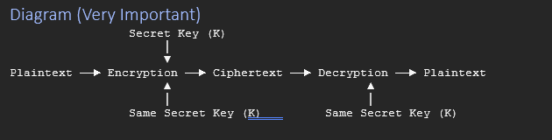

5.2 Examples of Symmetric Algorithms
- DES (Data Encryption Standard)
- Triple DES (3DES)

6. DES (Data Encryption Standard) (9.2.3)
Definition
DES (Data Encryption Standard) is a symmetric key encryption algorithm developed by IBM and adopted as a U.S. federal standard in 1977. It encrypts data using the same secret key for both encryption and decryption.

6.1 Key Features of DES
Feature | Value
Algorithm Type | Symmetric Key
Block Size | 64 bits
Effective Key Size | 56 bits
Encryption Rounds | 16 rounds
Same Key Used? | Yes
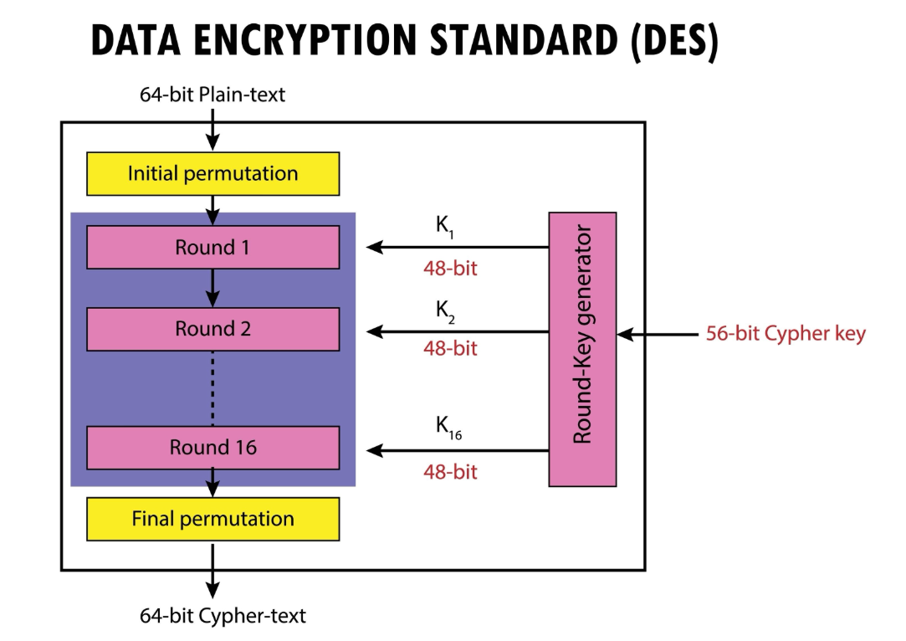
Figure: DES encryption structure

6.2 Working of DES

Step 1: Plaintext Input
- The sender provides a 64-bit plaintext.

Step 2: Initial Permutation (IP)
- The bits are rearranged according to a predefined permutation table.

Step 3: Split the Data
- The 64-bit block is divided into two equal halves:
  - Left Half (L)
  - Right Half (R)
- Each half contains 32 bits.

Step 4: 16 Rounds of Encryption
Each round performs operations such as:
- Expansion
- XOR with subkey
- Substitution (S-Boxes)
- Permutation
A different 48-bit subkey is used in each round.

Step 5: Swap Halves
- After the 16th round, the left and right halves are swapped.

Step 6: Final Permutation (IP⁻¹)
- The halves are combined and passed through a final permutation to produce the 64-bit ciphertext.

7. Asymmetric (Public Key) Cryptography (9.3)
Definition
Asymmetric Key Cryptography, also called Public Key Cryptography, is an encryption technique that uses two different but mathematically related keys: a Public Key (used for encryption) and a Private Key (used for decryption). Unlike symmetric encryption, the encryption and decryption keys are not the same.
Easy-to-remember: Asymmetric Cryptography uses two keys: a public key for encryption and a private key for decryption.

7.1 Working of Asymmetric Cryptography
- Step 1: The receiver generates two keys — a Public Key and a Private Key.
- Step 2: The Public Key is shared with everyone.
- Step 3: The sender encrypts the message using the receiver's Public Key.
- Step 4: The encrypted message is sent over the network.
- Step 5: The receiver decrypts the message using the Private Key.
Only the receiver possesses the private key, so only they can read the message.

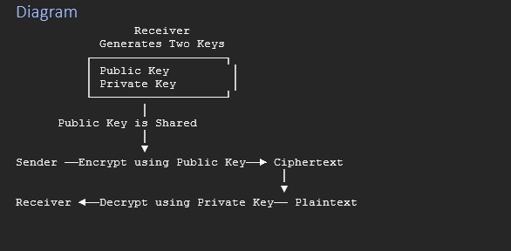7.2 Symmetric vs Asymmetric Cryptography
Feature | Symmetric | Asymmetric
Keys Used | One key | Two keys
Encryption Key | Same as decryption | Different from decryption
Speed | Fast | Slow
Security | Lower | Higher
Best For | Large data encryption | Secure key exchange, digital signatures
Example | DES | RSA

7.3 RSA Algorithm (Rivest–Shamir–Adleman)
RSA (Rivest–Shamir–Adleman) is the most widely used asymmetric (public-key) cryptographic algorithm. It uses two mathematically related keys:
- Public Key → Used for encryption
- Private Key → Used for decryption
RSA supports both encryption and digital signatures. Its security is based on the difficulty of factoring very large integers.
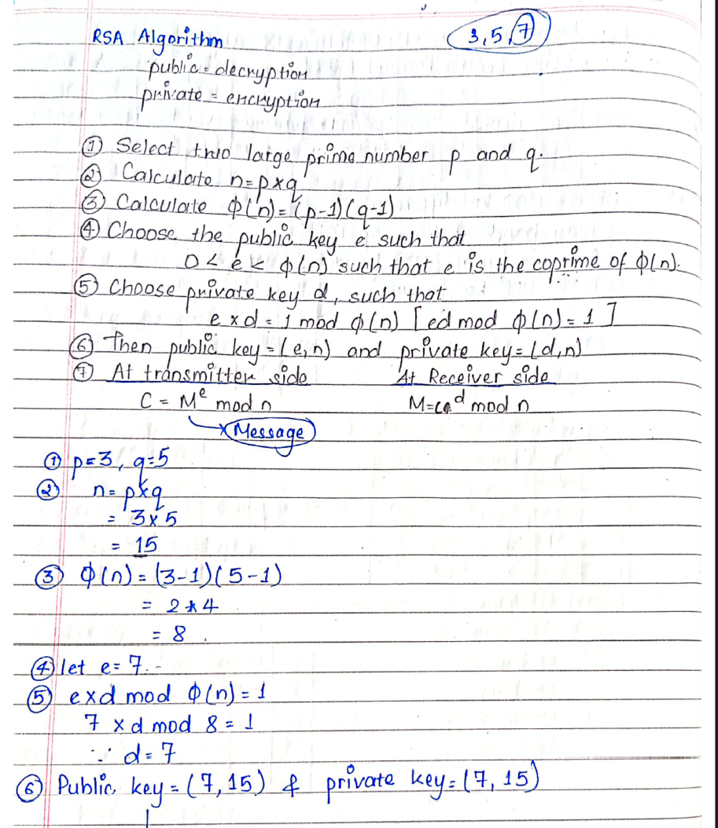
Figure: RSA key generation, encryption, and decryption steps
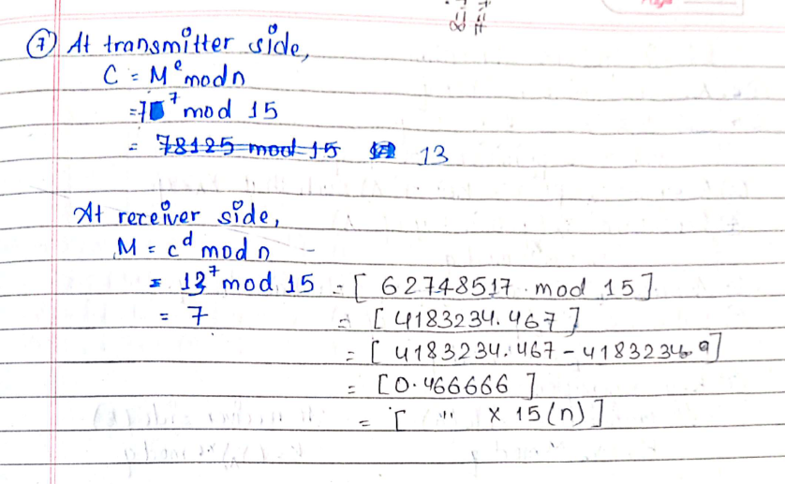
Figure: RSA worked example
8. Diffie–Hellman Key Exchange Algorithm (9.3.1)
Definition
Diffie–Hellman (DH) is a key exchange protocol that allows two parties to establish a shared secret key over an insecure network without transmitting the secret key itself. The shared secret key can then be used for encryption using a symmetric algorithm.
Easy-to-remember: Diffie–Hellman is a method of securely generating a shared secret key between two users over a public network.
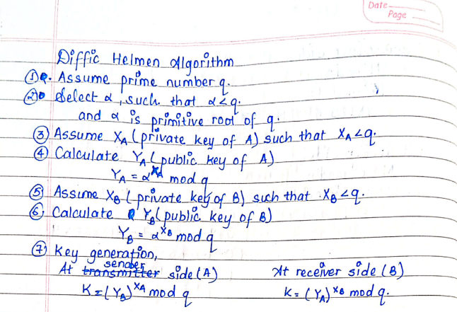
Figure: Diffie–Hellman key exchange
Diffie–Hellman does not encrypt data. It only establishes a shared secret key, which is later used by a symmetric encryption algorithm (such as AES or DES) to encrypt the actual data.

9. Kerberos
Definition
Kerberos is a network authentication protocol that provides secure authentication between a client and a server over an insecure network using secret-key cryptography and a trusted third party. It ensures that only authenticated users can access network resources.
Easy-to-remember: Kerberos is an authentication protocol that uses a trusted third party to verify the identity of users and servers.

9.1 Main Components
There are three main components:

1. Client
The user or computer requesting a service. Example: Your laptop.

2. Server
The computer providing the requested service. Example: Email server, database server.

3. Kerberos Server (Trusted Third Party)
This server authenticates users and issues tickets that prove the user's identity. Think of it as a trusted security officer who verifies everyone's identity before allowing access.

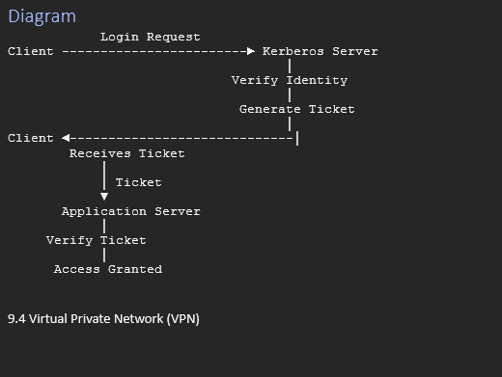

10. Virtual Private Network (VPN) (9.4)
Definition
A Virtual Private Network (VPN) is a technology that creates a secure and encrypted connection over a public network (such as the Internet), allowing users to communicate as if they were connected to a private network.
A VPN is a virtual network built on top of an existing physical network that provides secure communication for data transfer over public networks like the Internet.
Easy-to-remember: A VPN is a secure tunnel over the Internet that allows private communication between users or networks.
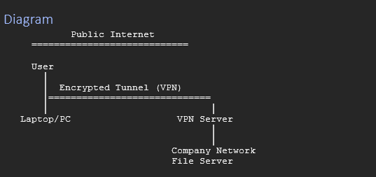

10.1 Types of VPN

1. Gateway-to-Gateway VPN (Site-to-Site VPN)
Definition
It connects two different networks through VPN gateways.
Example
Kathmandu Office ↔ Pokhara Office — both offices communicate securely over the Internet.

2. Host-to-Gateway VPN (Remote Access VPN)
Definition
It connects an individual user to a private network through a VPN gateway.
Example
An employee working from home connects securely to the company's office network.

3. Host-to-Host VPN
Definition
It creates a secure encrypted connection between two individual computers.
Example
Two computers securely exchanging confidential files.
11. Internet Protocol Security (IPSec)
Definition
IPSec (Internet Protocol Security) is a framework of open standards that provides secure communication at the Network Layer (IP layer) by authenticating and encrypting IP packets.
IPSec is commonly used to create VPNs over public networks and provides:
- Confidentiality
- Integrity
- Data origin authentication
- Replay protection
- Access control
Easy-to-remember: IPSec is a network-layer security protocol that provides secure communication by encrypting and authenticating IP packets.

12. Firewall
Definition
A Firewall is a network security system (hardware, software, or both) that monitors and controls incoming and outgoing network traffic based on predefined security rules. It acts as a barrier between a trusted internal network and an untrusted external network (such as the Internet).
Easy-to-remember: A firewall is a security system that filters network traffic and protects a private network from unauthorized access.

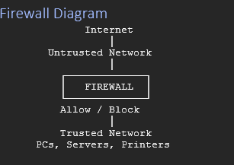

12.1 Types of Firewalls

1. Packet Filtering Firewall
Examines each packet individually. Filters traffic based on:
- Source IP address
- Destination IP address
- Port number
- Protocol
Advantage: Fast, simple.
Disadvantage: Cannot inspect packet contents.

2. Stateful Inspection Firewall
Keeps track of active network connections. Makes decisions based on both packet information and connection state.
Advantage: More secure than packet filtering.

3. Application-Level Gateway (Proxy Firewall)
Operates at the Application Layer. Inspects application data before forwarding requests.
Example
- HTTP Proxy
- FTP Proxy
Advantage: High security.
Disadvantage: Slower due to deep inspection.

4. Circuit-Level Gateway
Verifies TCP/UDP session establishment. Does not inspect the actual application data.

12.2 Difference Between Firewall and IPSec
Firewall | IPSec
Controls network traffic | Secures IP packets
Filters packets | Encrypts and authenticates packets
Protects network boundary | Protects data during transmission
Blocks unauthorized access | Ensures confidentiality and integrity

13. Digital Certificate
Definition
A Digital Certificate is an electronic document that verifies the identity of a person, organization, or website. It is issued by a Certificate Authority (CA) and contains the owner's public key, which is used for secure communication and authentication.

Contents of a Digital Certificate
A digital certificate typically contains:
- Certificate owner's name
- Public key
- Certificate serial number
- Validity period (Issue and Expiry date)
- Certificate Authority (CA) name
- Digital signature of the CA

14. Next Generation Network (NGN) (9.7)
Definition
Next Generation Network (NGN) is a packet-based communication network that provides multiple services such as voice, data, and multimedia over a single IP-based network. It separates the service layer from the transport layer, making the network more flexible and efficient.
Easy-to-remember: NGN is an IP-based network that integrates voice, video, and data services into a single network.

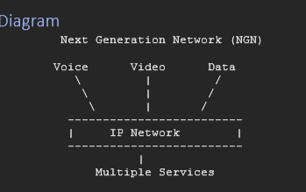

14.1 Advantages
- Reduces network operating costs.
- Provides multiple services over one network.
- Better bandwidth utilization.
- Easy integration of new services.
- Supports modern multimedia applications.
- Improves communication quality.

14.2 Applications
NGN is used in:
- Internet Telephony (VoIP)
- Video Conferencing
- IPTV
- Broadband Internet
- Multimedia Communication
- 5G and modern telecommunication networks

